ALCOHOL DETECTOR

WITH

BUZZER INDICATOR

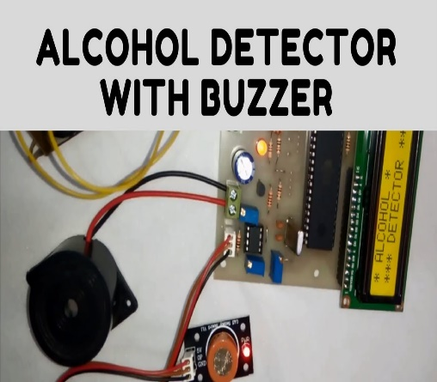

By: Nabin Bikram Thapa Magar

Subject: Internet of things

Coventry ID:10259959

**ABSTRACT**

Technology has been developing day by day and we are facing a new era of computer technology called Internet of things (IOT). IOT means system of billions of technological devices that are able to connect and exchange data over the network. Now, every technological devices that are able to connect with a network, comes under IOT Projects. In most cases, internet of things are usually be known as smart home, automation, home security systems etc.

Even though this project has its own purpose, it needs certain programming to run this project. Therefore, we need assembly language program for a certain technological device to work properly. Day by day, we are learning new technology and things, which makes possibility of IOT work endless. Technological things have evolved due to mixing of technologies with real-time analytics, machine learning and embedded systems.

Creativity of this new project is endless with amazing improvement in our lives. Therefore, my project Simple alcohol detector also comes under the basis of alcohol detector. The main purpose behind this project is to avoid vehicle accident and for the safety of people seating inside the vehicle. Alcohol detector project can be installed in vehicle and be used anywhere.

**Introduction**

This report is prototype for IOT alcohol detector project, a device that detects change in alcoholic gas content of surrounding. Here, alcoholic sensor checks the vapor of air and give its PH value to LCD display. Similar to every IOT projects, it combines network with hardware components. Nowadays, lot of accidents occurred due to negligence from driver and they often drink alcohol while driving. People always smoke and drink alcohol in prohibited places. Public transport is one of the places where smoking is strictly prohibited.

Smart city is never a smart, if it cannot solve small issues within the city.

In Police department, they can check content of alcohol in the breadth can by this project. Thus, arresting the people smoking and drinking alcohol in prohibited places.

This project uses Arduino mega controller, LCD display, MQ-3 sensor and buzzer. Lately, new features with app and database was added to make it more feasible. Our focus of this project is to make it cheaper as possible and it can be affordable by everyone.

In real life scenarios, many accidents occur due to negligence done by driver while being in a drunken state. So, drunk driver maybe the major reason behind lot of accidents. Driver have the responsibility of driving the vehicle to their destination so that they do not endanger the lives of others. So, this device alert driver the amount of alcohol consumed. In addition, police department can use this project to arrest driver if driver consumed alcohol. Drivers in their own vehicle for safety purposes can also easily install it.

**Aims:**

* This IOT project minimizes the cost as minimum as possible. In addition, because of its low cost, it can be used anywhere.
* This alcohol detector can detect alcohol gas from any mixed substances. In addition, laboratory can use this project to analyzed alcohol from any substances.
* Main aim of this project is to develop vehicle accident prevention by the use of this device to avoid any traffic accident based on driving. Traffic police can use this device to make their work easier.

**Objectives:**

* It only requires gas sensor, Arduino, and a display to make this project. In addition, materials was easily be found in any supermarket. Thus, making it budget friendly.
* This project can be used in police department for test purposes. Then, they will make good uses of this project. Therefore, they will strictly avoid any drunken driver.

**APPLICATIONS:**

* Many companies and organization can use this project to detect alcohol consumed by employees.
* Devices can be install in each passenger seats to detect alcohol components inside vehicle.

**Components:**

|  |  |
| --- | --- |
| Hardware name | Working |
| Liquid crystal display | It shows the output message detected by this IOT Project. |
| Buzzer | It makes noises when alcohol sensor crosses over threshold limit. |
| MQ-3 alcohol sensor | It checks and analyze the alcohol gas component. |
| Arduino Mega | It is the central unit of the system. It consist of 14 data pins of which 6 can be used as input analog and other 6 digital pins. |
| Adapter | It is used for giving power supply to its microcontroller. |
| Jumper wires | It is an electrical wire, that is used to interconnect the components the part of breadboard and other devices |

**Block Diagram:**

Block Diagram of the IOT alcohol sensor is shown in figure. It consists of power supply, Arduino Uno, Alcohol sensor mq-3 gas sensor, buzzer (Alarm), LCD display and a potentiometer.

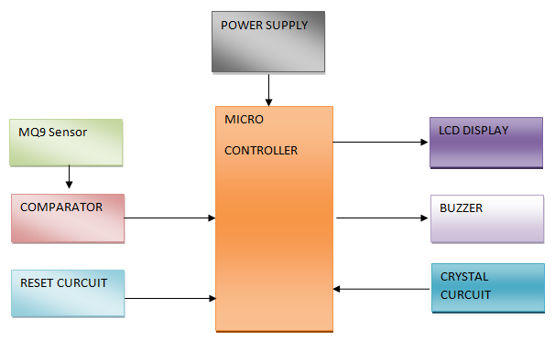

**Story Board:**

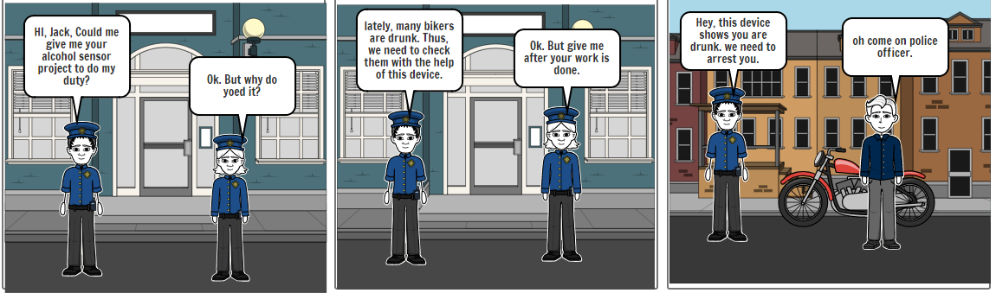

Hardware specification:

* Arduino Mega microcontroller was used from 8051 series microcontroller.
* LCD display with sixteen by 2 alphanumeric display.
* Buzzer is use for making noises when a certain criteria meets condition.
* 5V of transformer, voltage regulator was use to give power supply to the system.

Software Specification:

* Microcontroller written in assembly language.
* Hex file downloaded in microcontroller using Flash magic software.

**Algorithm:**

1. Start
2. Place a alcohol in front of a alcohol sensor
3. Alcohol sensor checks the air component within gas and give its value.
4. After that, if it value crosses over 300, it means alcohol is detected.
5. Buzzer makes noise
6. LCD shows alcohol detected.

**Working**

A simple alcohol detector project is use to detect alcohol gas sensor and send signal if it is an alcohol. This project can be use in college, campus, hospital and mainly in companies. In addition, vehicle can install this device to detect alcohol components inside vehicle. This device is very useful for traffic police as many driver are drunk which causes lot of accidents.

This project contains mq-2 gas sensor with Arduino as its microcontroller. However, we cannot connect gas sensor directly with Arduino because it only recognizes digital input. Therefore, we use comparator to connect gas sensor with Arduino. In comparator, one input goes from sensor and sends data from potentiometer. If sensor value detects over threshold limit, comparator would go high. Therefore, meaning Arduino understands given component is alcohol as it crosses more than threshold limit. For a better information, we have used buzzer to make noises whenever sensor detects alcohol. In addition to that, we have also used LCD display to show two messages: one it shows alcohol detected and other try again.

The data given by this system will be stored in database. Therefore, we use Node MCU with firebase to make a app where we store data given by the system.

**Future Scopes:**

This project still needs a lot of work. Now, this project can only detects the solely driver state but it could be further developed by implementing an alcohol sensor in each passenger seats to discover the gas air components once alcohol is detected. In addition, networking features can be add to this system, if needed. This system will also provide to each and every a voice alert and a message to the system monitor. If our customer needs extra features, then GPS and GSM will also be included in this project. Therefore, once alcohol is detected, we can know the location of the vehicle by GPS technology.

Every system needs a database to show its working process to customer. Even though our system detects the alcohol, there are nothing to store data done by system. Therefore, we will create a virtual app and a firebase database to store data recorded by the alcohol sensor IOT projects. In order to do this work, we need to use Node MCU as a microcontroller to connect database and the system.

**Conclusion:**

The main uses of this project is associated with “smoke sensor”, “alcohol sensor”, and “panic button”. If the person within vehicle, has consumed a alcohol, he/she will be alerted by this device. This project is much cheaper and can be affordable by anyone. In addition, this project is portable and can be implemented in any vehicle and devices. I made this project in order to create a smart city and healthy environment. Police department has its most uses from this project. This project is more or less based on lately alcohol sensor IOT projects. Therefore, new features like database and firebase on Node MCU was added to show it is fully utility of this project.

APPENDIX:

Youtube link: <https://www.youtube.com/watch?v=Ew-rFmPIsXs&feature=youtu.be>

**References:**

